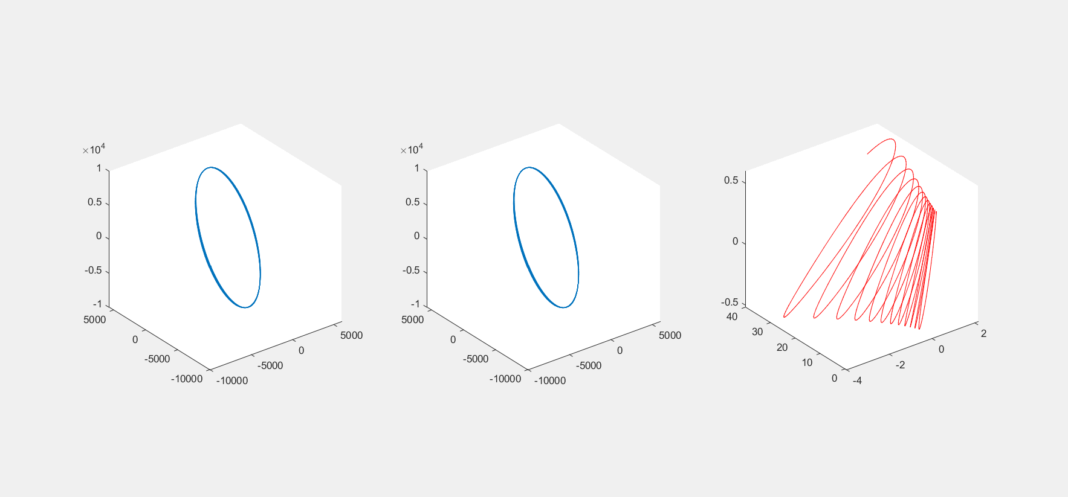

Trajectory of Deputy Satellite in Chief LVLH

Trajectory of Deputy Satellite In ECI

Trajectory of Chief Satellite In ECI